
Kingdom of Saudi Arabia
Ministry of Education
King Faisal University
College of Computer Sciences & Information Technology

Smart Safe Home System

by
Dhuha Hussain Al-Aithan
Ghofran Baqer Al-Hassan

Supervised by
Dr. Aida Al-Samawi

Table of Contents
LIST OF TABLES iii
LIST OF FIGURES iv
1. Problem Statement and Motivation 1
2. Requirements 1
2.1 Functional requirements: 1
2.2 Non-functional requirements: 2
3. System Design 2
3.1 Block Diagram 2
3.2 Network Topology 2
3.3 Message Format 3
4. Sensors 3
4.1 Purpose: 3
4.2 Wiring 4
4.3 Sampling Approach 5
5. Networking 5
5.1 Protocol/Module Choice 5
5.2 Addressing 5
5.3 Discovery/Pairing 5
5.4 Planned Reliability Method 6
6. Initial Implementation Results 6
6.1 Initial Wiring/Connection of the System 6
6.2 Updated Wiring/Connection of the System 7
7. Challenges and mitigation plan 7
9. Work Plan 8
References 9

LIST OF TABLES
Table 1: Hardware Components Wiring and Pin Connections 4
Table 2: Project Work Plan and Implementation Timeline 8

LIST OF FIGURES
Figure 1: System Block Diagram showing Arduino and Component Connections 2
Figure 2: Initial Hardware Prototype 6
Figure 3: Final Hardware Setup and Component Organization inside the Enclosure 7
Figure 4: Work Timeline 8

1. Problem Statement and Motivation
Fires and gas leak accidents in residential areas pose serious risks to human life and property in the Kingdom of Saudi Arabia. Recent 2024 statistics show that 84% of Saudi Arabian households rely on gas for cooking [1], and according to the General Authority for Statistics (GASTAT) and the Civil Defence, house fires alone caused over 1450 casualties in a single year [2]. Many homes either lack proper early detection systems or rely on single-sensor devices that may produce false alarms or fail to detect hazards in time. There is a need for a low-cost, reliable, and integrated safety system that can monitor multiple environmental factors simultaneously to improve early warning accuracy.
The motivation for this project is to develop a practical and affordable solution to improve home safety. Many existing safety devices detect only a single hazard, which can reduce accuracy and delay response. By integrating temperature, gas, and flame sensors into one system using an Arduino microcontroller, the proposed Smart Safe Home continuously monitors environmental conditions, displays real-time data on an LCD screen, and activates visual and audible alerts when danger is detected. The project demonstrates how microcontroller-based systems can provide a simple, reliable, and cost-effective approach to enhancing residential safety.

2. Requirements

2.1 Functional requirements:
- Continuously monitor temperature using the DHT22 sensor.
- Detect the presence of gases using the MQ-2 gas sensor.
- Detect the presence of flame using the KY-026 flame sensor.
- Display real-time sensor readings on the 16×2 I2C LCD screen.
- Establish a wireless connection with an Android smartphone using the HC-05 Bluetooth module to transmit and view real-time data.
- Compare sensor readings against predefined safety thresholds.
- Activate a buzzer when a hazardous condition is detected.
- Turn on specific LED indicators when a hazardous condition is detected (BLUE: safe, RED: danger).
- Operate in real-time and update readings at regular intervals.
- Reset alerts automatically when environmental conditions return to safe levels.

2.2 Non-functional requirements:
- Be low-cost and built using affordable, widely available components.
- Operate reliably with minimal false alarms.
- Provide fast response time to detected hazards.
- Be energy efficient for continuous operation.
- Have a simple and user-friendly display interface.
- Be compact and suitable for home environments.

3. System Design

3.1 Block Diagram
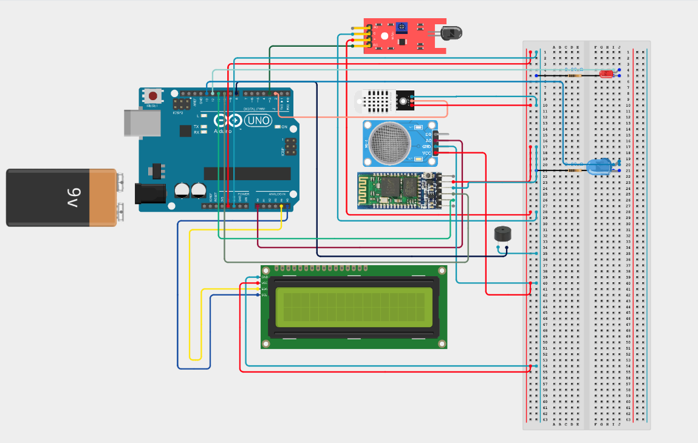
Figure 1: System Block Diagram showing Arduino and Component Connections

3.2 Network Topology
The Smart Safe Home system follows a centralized (star) network topology, with the Arduino Uno acting as the central node. All sensors and output devices are directly connected to the Arduino, which processes sensor data and controls the system outputs.
- Sensors: Temperature (DHT22), gas (MQ-2), and flame (KY-026) sensors send environmental data to the Arduino.
- Output Devices: LCD, LEDs, and a buzzer receive commands from the Arduino based on sensor readings.
- Communication Device: The HC-05 Bluetooth module transmits data from the Arduino to the Android smartphone wirelessly.
- Communication: Each sensor sends data directly to the Arduino; no sensor-to-sensor communication occurs. The Arduino makes decisions and updates all outputs accordingly.
This topology ensures a simple, reliable, and low-latency system, making it easy to add or replace components without affecting the overall network.

3.3 Message Format
​The system uses a plain-text string format separated by a pipe symbol (|) to transmit information from the Arduino to the Android smartphone application (Serial Bluetooth Terminal). To ensure the user receives clear information, the data is categorized into two distinct types:
- ​Emergency Alert Format
When a sensor exceeds a predefined safety threshold (e.g., gas levels above 115), the system sends an alert string.
Structure: ALERT: [Hazard Type]! Value: [Reading]
Example: ALERT: Gas Leak! Value: 117
This format is designed for immediate human readability in the terminal and triggers the alarm logic within the mobile app.

- ​Periodic Status Format (Normal Operation)
When conditions are safe, the system sends a "Status Update" containing all environmental data points.
Structure: Status: OK | Temp: [Value]C | Hum: [Value]% | Gas: [Value]
Example: Status: OK | Temp: 26.7C | Hum: 40% | Gas: 115

4. Sensors

4.1 Purpose:
- Temperature Sensor (DHT22): Monitors the temperature to detect abnormal heat that may indicate a fire.
- Gas Sensor (MQ-2): Detects the presence of combustible or hazardous gases in the environment.
- Flame Sensor (KY-026): Detects the presence of fire or flames in the monitored area.

4.2 Wiring

Table 1: Hardware Components Wiring and Pin Connections
Components | Arduino Pin | Breadboard Location
Flame Sensor (KY-026) | Pin 3  +  G | D0  Optional Port (+)  Optional Port (-)
Gas Sensor (MQ-2) | Pin A0  GND  VCC | A0  Optional Port (-)  Optional Port (+)
Temperature Sensor (DHT22) | Pin 2  -  + | Out  Optional Port (-)  Optional Port (+)
HC-05 Bluetooth Module | Pin 10  Pin 11  GND  VCC | TXD  RXD  Optional Port (-)  Optional Port (+)
LCD Display (SDA) | Pin A4
LCD Display (SLA) | Pin A5
LCD Display (GND) |  | Optional Port (-)
LCD Display (VCC) |  | Optional Port (+)
Red LED (Alarm) | Pin 12 | Row 4 & 5
Blue LED (Safe) | Pin 13 | Row 20 & 21
Buzzer | Pin 8 | Optional Port (+)  Optional Port (-)
System VCC | 5V Pin | Red Rail (+)
System GND | GND Pin | Blue Rail (-)

The system is powered by a battery connected to the Arduino.

4.3 Sampling Approach
The system implements a periodic sequential sampling and transmission approach within the loop() function. In every iteration, the Arduino reads the gas sensor using analogRead(GAS_PIN), the flame sensor using digitalRead(FLAME_PIN), and the temperature sensor using dht.readTemperature(). These readings are then evaluated against predefined thresholds (gas level > 115, flame detected, or temperature > 45°C) to determine the system state; the system then packages the processed values and broadcasts them to the paired Android mobile device via the Bluetooth module. After processing the data and updating the LCD, LEDs, and buzzer, the program executes a delay(500) statement, which sets the sampling interval to 500 milliseconds. Therefore, all sensors are sampled every 0.5 seconds, enabling continuous real-time monitoring of environmental conditions.

5. Networking

5.1 Protocol/Module Choice
- Module: HC-05 Bluetooth Module.
- ​Protocol: Bluetooth Classic (v2.0) using the Serial Port Profile (SPP). This protocol acts as a wireless "virtual serial cable," allowing the Arduino to transmit the delimited sensor strings to the mobile app exactly as it would to a computer via USB.

5.2 Addressing
- MAC Address: Each HC-05 module has a unique, factory-assigned 48-bit hardware address for identification.
- ​Network Topology: The connection is a Point-to-Point (P2P) link. In this setup, the Arduino (acting as the Slave) and the Android Smartphone (acting as the Master) communicate directly with each other, eliminating the need for intermediate hardware like routers or access points.

5.3 Discovery/Pairing
- Pairing Method: The system uses a standard PIN code ("1234") to verify the connection. This ensures that only authorized mobile devices can access the sensor data.
Connection Process:
- ​Scanning: The Android phone searches for the Bluetooth module's signal.
- ​Pairing: Once found, the user enters the PIN to create a "trusted bond" between the phone and the Arduino.
- ​Data Link: After pairing, the mobile app opens a private channel to start receiving the real-time sensor readings.

5.4 Planned Reliability Method
- Complete Messages: Every data packet ends with a Newline (\n). This acts like the "period" at the end of a sentence, telling the mobile app exactly when one full message has finished so the data doesn't get cut off.
- ​Stable Connection: Because the phone and Arduino talk directly (P2P) without using a Wi-Fi router or the internet, there are fewer delays. This ensures that emergency alerts, like a gas leak, show up on the phone instantly.

6. Initial Implementation Results

6.1 Initial Wiring/Connection of the System

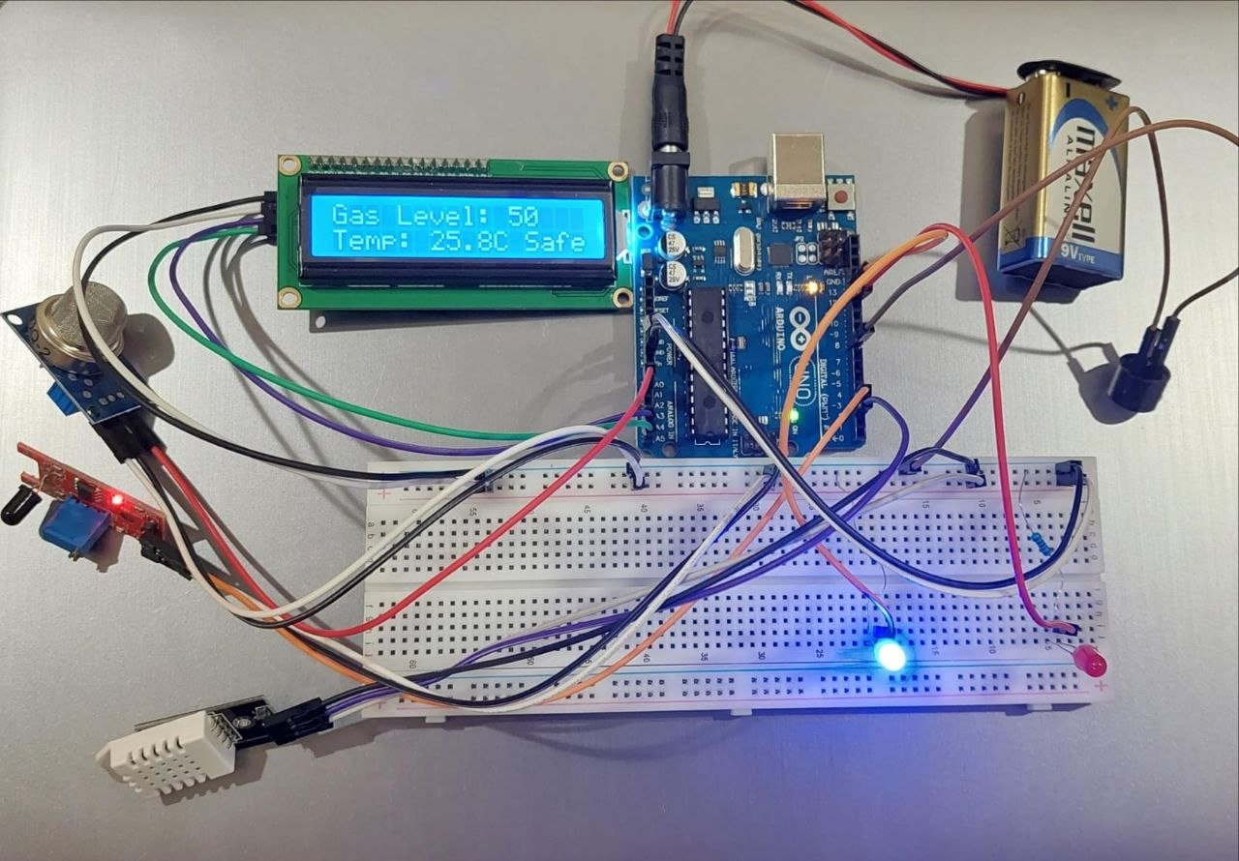
Figure 2: Initial Hardware Prototype

The initial system proved functional and responsive to its surrounding environment.

6.2 Updated Wiring/Connection of the System

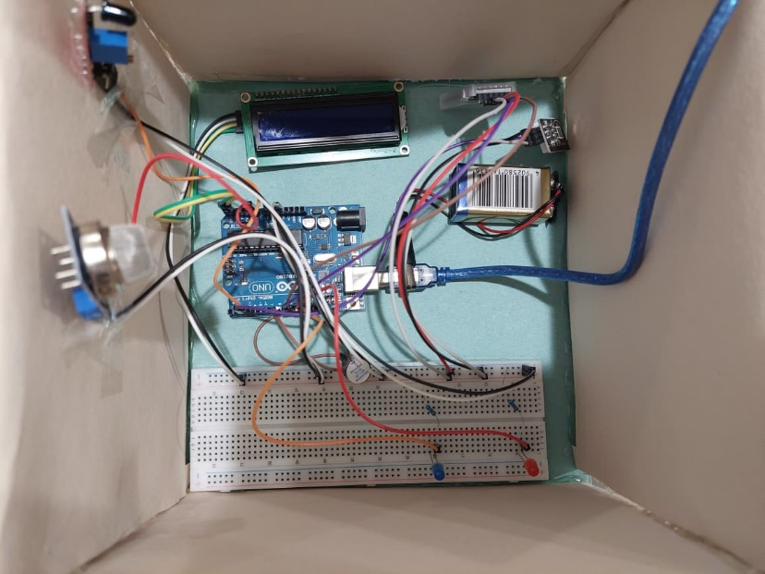

Figure 3: Final Hardware Setup and Component Organization inside the Enclosure

7. Challenges and mitigation plan

Challenge 1: Power Supply Instability
- Description: During initial testing with a standard 9V battery, the system experienced frequent resets and LCD flickering. This occurred because the battery could not provide the high peak current required to power the Arduino and the sensors simultaneously.
- Mitigation: The system was transitioned to a direct 5V DC power supply via a USB cable. This provided a stable current, ensuring the LCD stayed clear and preventing system crashes during alerts.

Challenge 2: High-Sensitivity Gas Detection
- Description: This low value was selected to ensure early detection of gas leaks. However, such high sensitivity made the system prone to false alarms caused by minor environmental fluctuations or initial sensor noise.
- Mitigation: We monitored real-time data via the Serial Monitor to establish a baseline for normal air quality. The code logic was then refined to ensure the alarm only triggers when the reading remains consistently above the defined threshold, balancing early warning with system stability.

9. Work Plan

Table 2: Project Work Plan and Implementation Timeline
Start W | End W | Key Activities
1 | 4 | (Ramadan Phase): Preliminary research and initial drafting
5 | 6 | (Shawwal Phase): Finalizing idea, hardware selection, and requirements
7 | 8 | Hardware assembly, coding, and updating technical sections
9 | 10 | Finalizing the core M1 report and first submission
11 | 12 | Bluetooth (HC-05) integration and report refinement
13 | 13 | Finalizing presentation and updated system documentation
14 | 15 | Final results analysis and project finalization

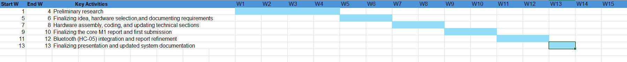
Figure 4: Work Timeline

References

[1] General Authority for Statistics. (2024, June 3). GASTAT releases household energy statistics 2024.
[2] Saudi Gazette. (2019, May 14). House fires cause over 1,450 casualties in a year.

